Inexpensive Vacations: Illinois, Michigan and Wisconsin National and State Parks May 04, 2016



1. Abraham Lincoln Home National Historical Site

Springfield, Illinois. Husband, Father, and President - Abraham Lincoln believed in the ideal that everyone in America should have the opportunity to improve his/her economic and social condition. Lincoln’s life was the embodiment of that idea. We know him as the sixteenth president but he was also a spouse, parent, and neighbor who experienced the same hopes, dreams, and challenges of life that are still experienced by many people. Source: US National Park Service

Read more: [http://www.mycouponbuddy.com#ixzz4EWNWNWZv](http://www.mycouponbuddy.com/#ixzz4EWNWNWZv)

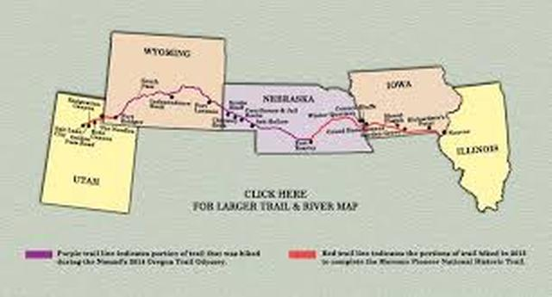

2. Mormon Pioneer National Heritage Trail

Nauvoo, Illinois. History & Culture - Joseph Smith's 1820 vision led to the organization of the Mormon faith. The history of the Mormon Trail cannot be understood without an awareness of the Mormon religion itself. The great Mormon migration of 1846-1847 was but one step in the Mormons' quest for religious freedom and growth. Source: US National Park Service

Read more: [http://www.mycouponbuddy.com#ixzz4EWNYSPZc](http://www.mycouponbuddy.com/#ixzz4EWNYSPZc)

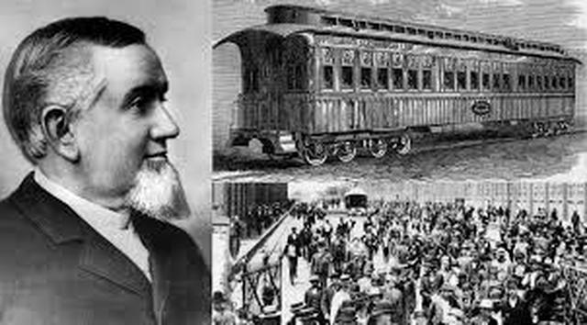

3. Pullman National Monument

Chicago, Illinois. Pullman National Monument tells the story of American opportunity. - Diverse people whose stories intertwine in Pullman sought opportunity. Some succeeded. Others were limited—by race, gender, or economic status. Their stories came together in the town of Pullman, a planned community famed for its urban design and architecture. Designed as a utopia—it was a place to provide workers with a safe community, a better standard of living, and life without social ills. Source: US National Park Service

Read more: [http://www.mycouponbuddy.com#ixzz4EWNabi17](http://www.mycouponbuddy.com/#ixzz4EWNabi17)

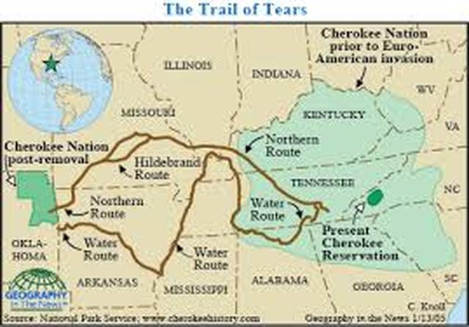

4. Trail of Tears National Historic Trail

Jonesboro, Illinois. - A Journey of Injustice - Remember and commemorate the survival of the Cherokee people, forcefully removed from their homelands in Georgia, Alabama, and Tennessee to live in Indian Territory, now Oklahoma. They traveled by foot, horse, wagon, or steamboat in 1838-1839. Source: US National Park Service

Read more: [http://www.mycouponbuddy.com#ixzz4EWNdf8BN](http://www.mycouponbuddy.com/#ixzz4EWNdf8BN)

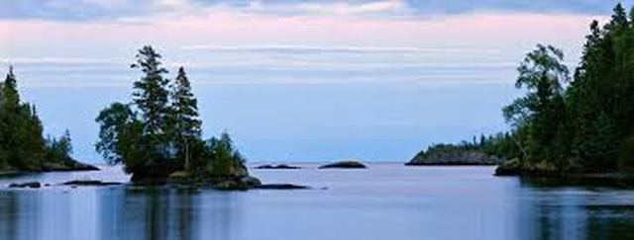

5. Isle Royale National Park

Houghton, Illinois. Your Invitation to a Superior Wilderness Experience! - Explore a rugged, isolated island, far from the sights and sounds of civilization. Surrounded by Lake Superior, Isle Royale offers unparalleled solitude and adventures for backpackers, hikers, boaters, kayakers, canoeists and scuba divers. Here, amid stunning scenic beauty, you'll find opportunities for reflection and discovery, and make memories that last a lifetime. Source: US National Park Service

Read more: [http://www.mycouponbuddy.com#ixzz4EWNfUnLy](http://www.mycouponbuddy.com/#ixzz4EWNfUnLy)

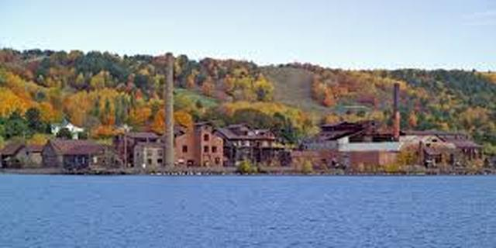

6. Keweenaw National Historical Site

Calumet, Illinois. Keweenaw's Copper Story - From 7,000 years ago to the 1900s people mined Keweenaw copper. Native peoples made copper into tools and trade items. Investors and immigrants arrived in the 1800s in a great mineral rush, developing thriving industries and cosmopolitan communities. Though the mines have since closed, their mark is still visible on the land and people. Source: US National Park Service

Read more: [http://www.mycouponbuddy.com#ixzz4EWNhEhdc](http://www.mycouponbuddy.com/#ixzz4EWNhEhdc)



7. Motor Cities National Heritage Area

Detroit, Michigan. MotorCities National Heritage Area - If you are interested in automotive history, then MotorCities National Heritage Area is the place to be. Tour the factory where Henry Ford created and built the Model T. Learn the stories behind the creation of General Motors and DamilerChrysler. Come with us and learn about the long and sometimes tenuous relationship between Labor and Industry while experiencing southeast Michigan. Source: US National Park Service

Read more: [http://www.mycouponbuddy.com#ixzz4EWNkwzCK](http://www.mycouponbuddy.com/#ixzz4EWNkwzCK)

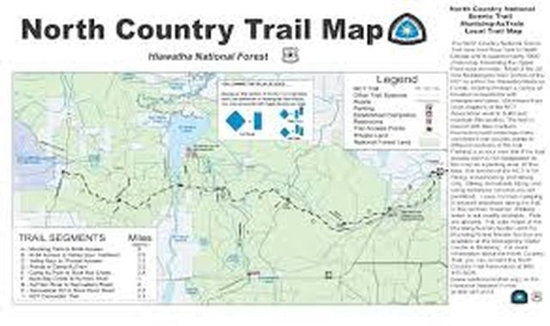

8. North Country National Scenic Trail

Adventures Await in Seven States - From New York to North Dakota, you're never far from a great outdoor adventure. When completed the trail will be the longest continuous hiking trail in the United States. The trail links scenic, natural, historic, and cultural areas across seven states allowing visitors to experience a variety of northern landscapes. Come and experience your America, at a walking pace. Source: US National Park Service

Read more: [http://www.mycouponbuddy.com#ixzz4EWNmbQ8R](http://www.mycouponbuddy.com/#ixzz4EWNmbQ8R)

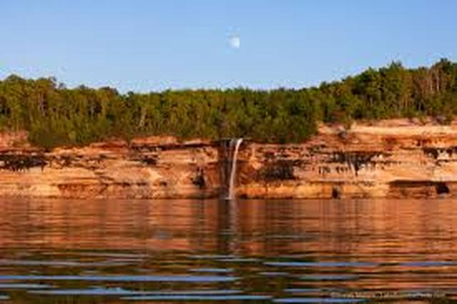

9. Pictured Rocks National Lakeshore

Munising, Michigan. Wild Beauty on the Lake Superior Shore - Sandstone cliffs, beaches, sand dunes, waterfalls, lakes, forest, and shoreline beckon you to visit Pictured Rocks National Lakeshore. Hiking, camping, sightseeing, and four season outdoor opportunities abound. The lakeshore hugs the Lake Superior shoreline for more than 40 miles. Lake Superior is the largest, deepest, coldest, and most pristine of all the Great Lakes Source: US National Park Service

Read more: [http://www.mycouponbuddy.com#ixzz4EWNoI7Ib](http://www.mycouponbuddy.com/#ixzz4EWNoI7Ib)

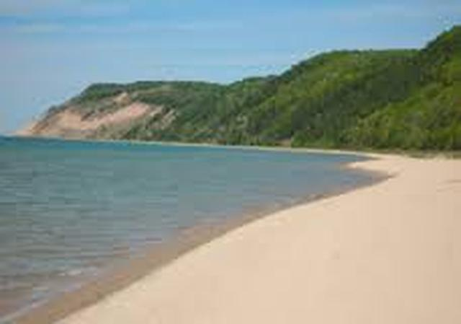

10. Sleeping Bear Dunes National Lakeshore

Empire, Michigan. A place in which to play, dream, refresh, create - Miles of sandy beaches, bluffs that tower 450’ above Lake Michigan, lush forests, clear inland lakes, unique flora, and fauna make up the natural world of Sleeping Bear Dunes. High dunes afford spectacular views across the lake. An island lighthouse, US Life-Saving Service stations, coastal villages, and picturesque farmsteads reflect the park’s rich maritime, agricultural, and recreational history. Source: US National Park Service

Read more: [http://www.mycouponbuddy.com#ixzz4EWNs0o7S](http://www.mycouponbuddy.com/#ixzz4EWNs0o7S)

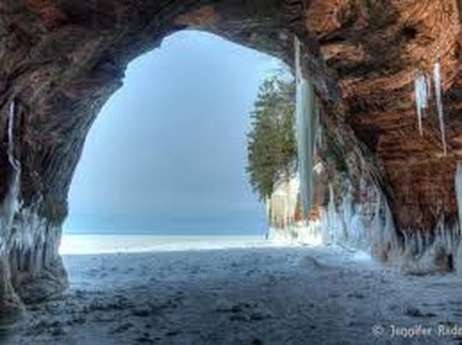

11. Apostle Islands National Lakeshore

Bayfield, Wisconsin. Though Apostle Islands National Lakeshore features several points of interest located on the mainland, most people consider the islands themselves to be the most rewarding destination. The Apostle Islands offer outstanding opportunities for active, outdoor enjoyment and recreation. Source: US National Park Service

Read more: [http://www.mycouponbuddy.com#ixzz4EWNtgK37](http://www.mycouponbuddy.com/#ixzz4EWNtgK37)

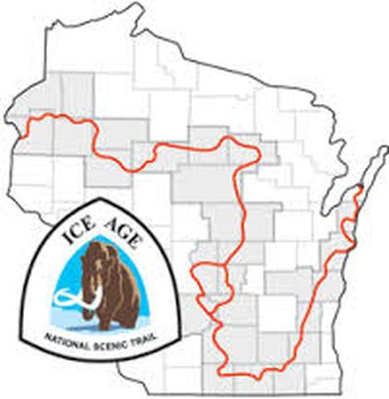

12. Ice Age National Scenic Trail

Madison, Wisconsin. A Mammoth Walk - A mere 15,000 years ago during the Ice Age, much of North America lay under a huge glacier. Mammoths, saber tooth cats, and cave lions roamed the earth! Some of the best evidence of this glacier is found in Wisconsin such as the state’s many lakes, river valleys, gently rolling hills and ridges. The nearly 1,200 mile Ice Age National Scenic Trail, established in 1980, traces the glacier's edge. Source: US National Park Service

Read more: [http://www.mycouponbuddy.com#ixzz4EWNvR300](http://www.mycouponbuddy.com/#ixzz4EWNvR300)

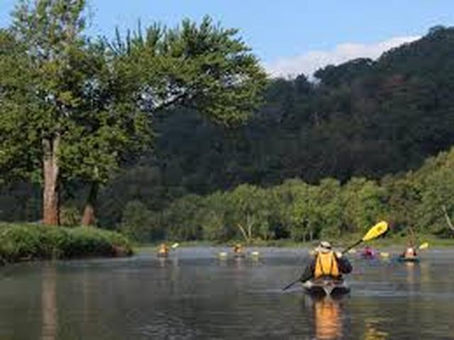

13. Saint Croix National Scenic Parkway

Saint Croix Falls, Wisconsin. Rivers to Explore - Grab your paddle and your longing for adventure and head to the St. Croix and Namekagon rivers! Together they form the St. Croix National Scenic Riverway, offering over 200 miles of clean water that glides and rushes through a forested landscape. Paddle, boat, fish, and camp among this wild and scenic beauty. Hiking and historic towns also beckon, if you can bear to leave the cool water. Source: US National Park Service

Read more: [http://www.mycouponbuddy.com#ixzz4EWO0a2SY](http://www.mycouponbuddy.com/#ixzz4EWO0a2SY)

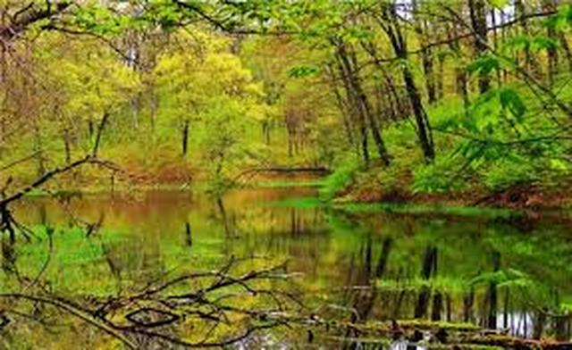

14. Chippewa Moraine State Recreational Area

New Auburn, Wisconsin. Situated along the Ice Age National Scenic Trail, the Chippewa Location Moraine State Recreation Area offers unspoiled beauty with kettle lakes and many glacial features. The Chippewa Moraine is one of nine units of the Ice Age National Scientific Reserve. Hiking, snowshoeing, outpost camping, fishing and bird watching are popular activities. The David R. Obey Ice Age Interpretive Center houses first-class glacial, cultural and natural history displays. Source: Wisconsin State Parks

Read more: [http://www.mycouponbuddy.com#ixzz4EWO2FtOn](http://www.mycouponbuddy.com/#ixzz4EWO2FtOn)

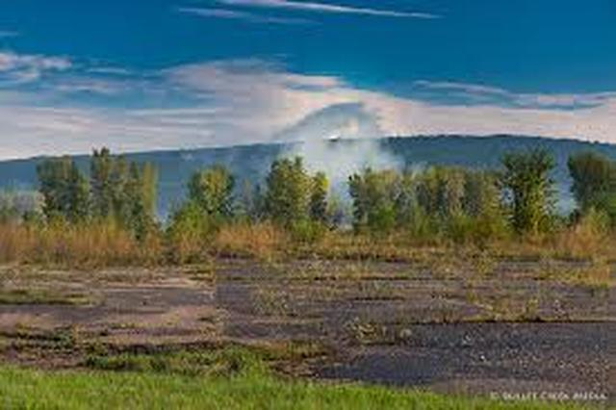

15. Sauk Prairie State Recreation Area

Baraboo, Wisconsin. Sauk Prairie Recreation Area was once designated as an army ammunition plant Location that manufactured nitrocellulose-based propellants during World War II, the Korean War and the Vietnam War. It was the largest munitions factory in the world during World War II. The plant was declared excess to the Army's needs and has since been transferred to the state and other owners for recreation, conservation, and research. Visitors may hunt, trap, hike, bird watch, pick mushrooms and berries, study nature, take photographs and other traditional outdoor activities. You may also drive, bike or ride horses on the roads within the complex that are open. Roads are in variable condition; some have many ruts and potholes. Source: Wisconsin State Parks

Read more: [http://www.mycouponbuddy.com#ixzz4EWO3uEbp](http://www.mycouponbuddy.com/#ixzz4EWO3uEbp)

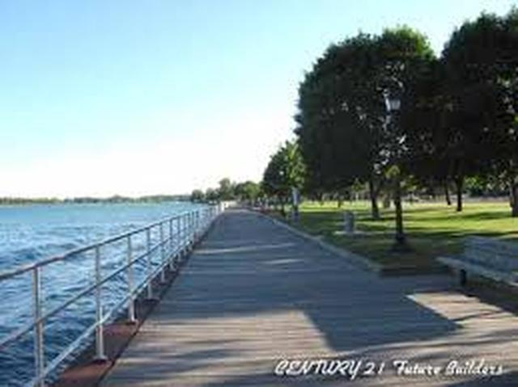

16. Algonac State Park

Marine City, Michigan. Algonac State Park's major attraction is viewing freighters of the world along the one-half mile of St. Clair River frontage. Algonac is also home to rare habitats, the lake plain prairies and oak savannas that provide places to view prairie plants, wildlife, and butterflies. Source: Michigan State Parks

Read more: [http://www.mycouponbuddy.com#ixzz4EWO8lyaI](http://www.mycouponbuddy.com/#ixzz4EWO8lyaI)

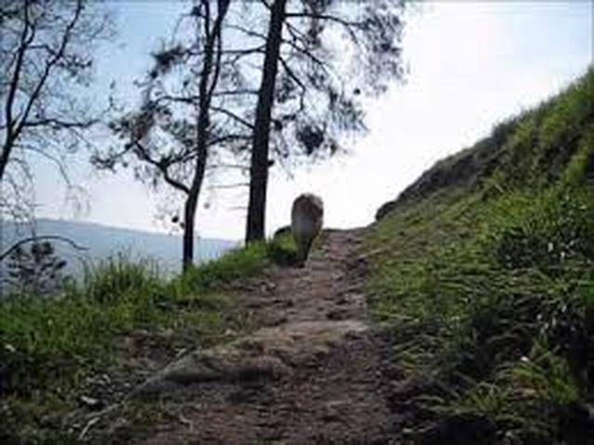

17. Bald Mountain Recreation Area

Bald Mountain Recreation Area is a 4,637-acre state park located near Lake Orion, Michigan off M-24. It consists of some of most the rugged terrain in southeastern Michigan. The recreation area is composed of a North Unit and a South Unit, which are not contiguous. The South Unit itself includes two parts separated by M-24, but the section west of M-24 has no recreational facilities or trails and is primarily undeveloped forest and grassy plains segmented by a few through-roads. Source: Michigan State Parks

Read more: [http://www.mycouponbuddy.com#ixzz4EWOATyLS](http://www.mycouponbuddy.com/#ixzz4EWOATyLS)



18. Belle Isle Park

Detroit, Michigan. Belle Isle Park, is a 982-acre island park in the Detroit River, between the United States mainland and Canada, managed as a Michigan state park. The island is home to the Belle Isle Aquarium, the Belle Isle Conservatory, the Belle Isle Nature Zoo, the Detroit Yacht Club on an adjacent island, the James Scott Memorial Fountain, the Dossin Great Lakes Museum, a Coast Guard station, a municipal golf course and numerous monuments. The island includes a half-mile swimming beach. Source: Michigan State Parks

Read more: [http://www.mycouponbuddy.com#ixzz4EWOCKhzb](http://www.mycouponbuddy.com/#ixzz4EWOCKhzb)

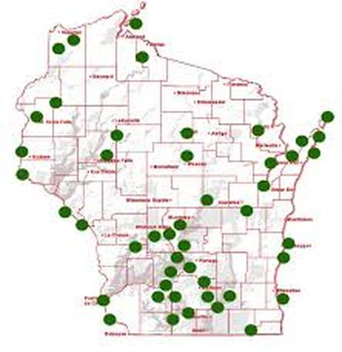

19. Wisconsin State Parks

Use the internet to search for a list of the over 200 Wisconsin State Parks for locations, directions and amenities.

Read more: [http://www.mycouponbuddy.com#ixzz4EWOFcp7B](http://www.mycouponbuddy.com/#ixzz4EWOFcp7B)

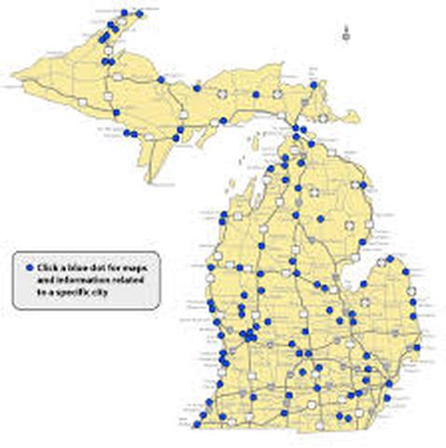

20. Michigan State Parks

Use the internet to search for a list of the over 700 Michigan State Parks for locations, directions and amenities.

Read more: [http://www.mycouponbuddy.com#ixzz4EWOHTfRM](http://www.mycouponbuddy.com/#ixzz4EWOHTfRM)

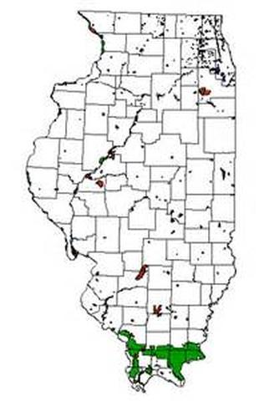

21. Illinois State Parks

Use the internet to search for a list of the many Illinois State Parks for locations, directions, and amenities.

Read more: [http://www.mycouponbuddy.com#ixzz4EWOJBxOX](http://www.mycouponbuddy.com/#ixzz4EWOJBxOX)